Change 1
Can we add any more filters to the QMS Mashup on top of the selection fields available against the custom list? I’ve exhausted the three selection fields and want to find out if there’s a way to add anymore filters? If no, could you please remove the approval status and request status filters from the SDK?
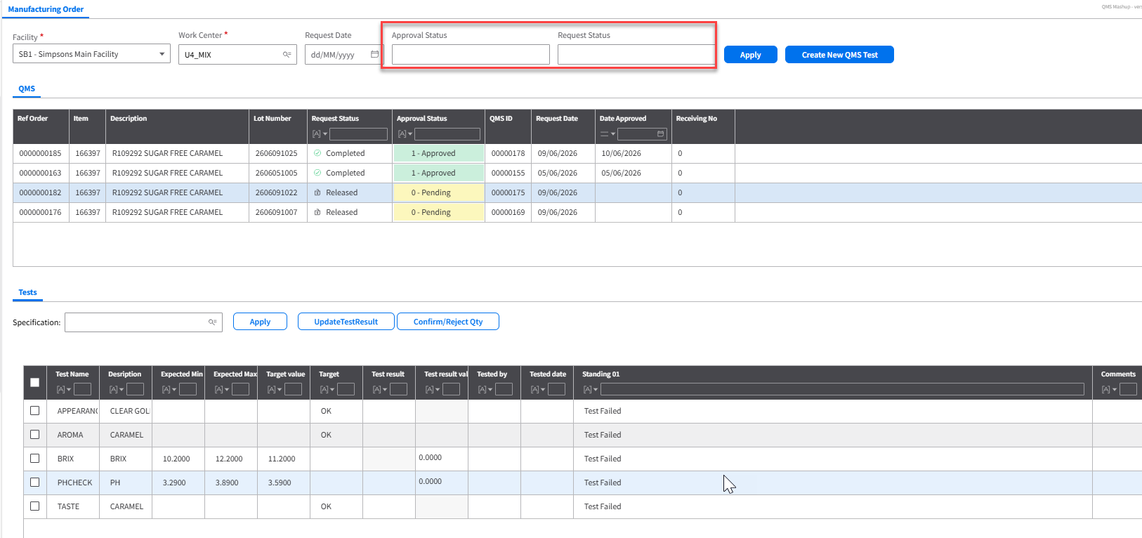

Change 2
I’ve added location (RHWHSL) and container (RHCAMU) fields to the custom list view LstQIRequest. Could these two fields be added to the QMS tab on QMS SDK?
